PART I Picture Questions (file No.3808)
DRILL 1
1. (a) (b) (c) (d) 問題ID B-01-1 2. (a) (b) (c) (d) 問題ID B -01-2
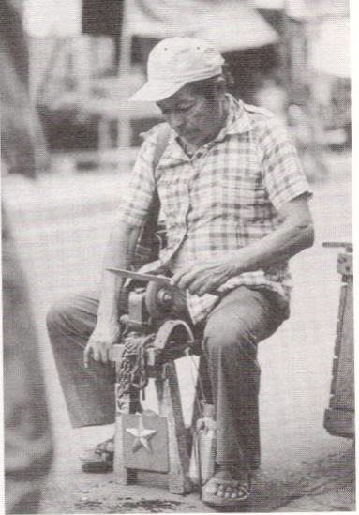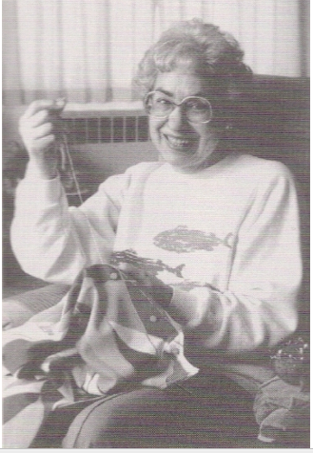

3. (a) (b) (c) (d) 問題ID B -01-3 4. (a) (b) (c) (d) 問題ID B -01-4
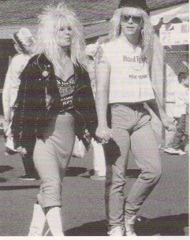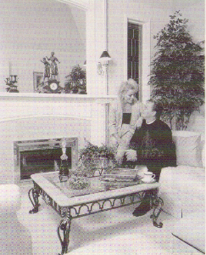

DRILL 2
1. (a) (b) (c) (d) 問題ID B -01-5 2. (a) (b) (c) (d) 問題ID B -01-6
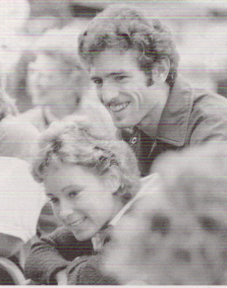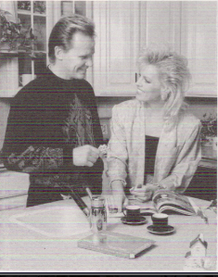

3. (a) (b) (c) (d) 問題ID B -01-7 4. (a) (b) (c) (d) 問題ID B -01-8
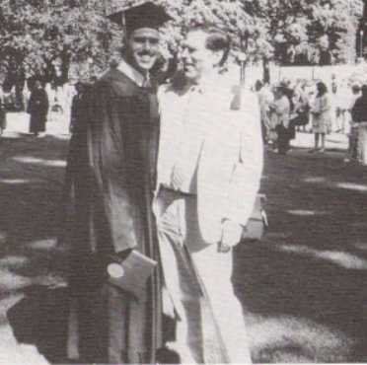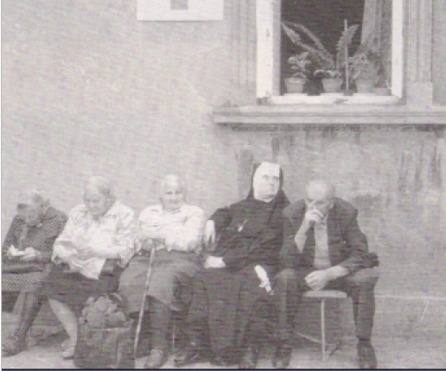

------------------------------------------------------------------------------------------------------------------------------------------
PART II Question-Response
DRILL 11
Directions: You will hear a question or statement and three responses spoken in English. They will be spoken only one time and will not be printed in your test book. Select the best response to the question or statement and mark the letter (a), (b), or (c) on your answer sheet.

1. (a) (b) (c) 問題ID B -02-1

2. (a) (b) (c) 問題ID B-02-2

3. (a) (b) (c) 問題ID B -02-3

4. (a) (b) (c) 問題ID B -02-4

5. (a) (b) (c) 問題ID B -02-5

6. (a) (b) (c) 問題ID B -02-6

7. (a) (b) (c) 問題ID B -02-7

8. (a) (b) (c) 問題ID B -02-8

------------------------------------------------------------------------------------------------------------------------------------------
PART III Short Conversations
DRILL 21
Directions: You will hear some conversations between two people. You will be asked to answer three questions about what the speakers say in each conversation. Select the best response to each question and mark the letter (a), (b), (c), or (d) on your answer sheet. The conversations will be spoken only one time and will not be printed in your test book.

1. What do the man and woman probably do? 問題ID B -03 –1
(a) Teachers. (b) Students. (c) Doctors. (d) Hospital workers.

2. Why was the lecture useful, according to the man? 問題ID B -03 –2
(a) He is interested in science.
(b) Science helps him to understand.
(c) The City University will write his essay.
(d) It will help him complete some school work.

3. What is the matter with the woman’s sister? 問題ID B -03 –3
(a) She ate too much food. (b) She has a health problem.
(c) She missed her classes. (d) She has to take a test.
- - - - - - - - - - - - - - - - - - - - - - - - - - - - - - -
4. According to the woman’s friend, what is the best way to get to Tokyo? 問題ID B -03 –4
(a) By overnight bus. (b) By plane. (c) By train. (d) By car.

5. Why did the man dislike traveling by bus to Tokyo? 問題ID B -03 –5
(a) It was too crowded. (b) It was fast an cheap.
(c) The seats were not comfortable. (d) The plane was cheaper.

6. How would the woman like to travel to Tokyo? 問題ID B -03 –6
(a) By bus. (b) By plane. (c) By train. (d) By car.

------------------------------------------------------------------------------------------------------------------------------------------
DRILL 22

1. Who does the man want to make an appointment with? 問題ID B -04 –1
(a) The dentist. (b) The doctor. (c) The eye doctor. (d) The lecturer.

2. What time does the man want to come? 問題ID B -04 –2
(a) 9:30. (b) 10:00. (c) 10:30. (d) 11:00.

3. What advice does the woman give? 問題ID B -04 –3
(a) Go somewhere else. (b) Go to the lecture at the university.
(c) Come on a different day (d) Come in the afternoon.
- - - - - - - - - - - - - - - - - - - - - - - - - - - - - - -
4. Where does this conversation probably take place? 問題ID B -04 –4
(a) In San Francisco. (b) At a travel agency.
(c) On an airplane. (d) At the train station.

5. What kind of ticket does the woman want? 問題ID B -04 –5
(a) Business class. (b) Tourist class. (c) First class. (d) Economy class.

6. Which tickets are cheaper than usual? 問題ID B -04 –6
(a) Business class. (b) Tourist class. (c) First class. (d) Economy class.

------------------------------------------------------------------------------------------------------------------------------------------
DRILL 23
1. Why does the woman call the man? 問題ID B -05 –1
(a) To invite him to Tokyo. (b) To order him to go to Tokyo.
(c) To advise him to go to Tokyo. (d) To suggest that he goes to Tokyo.

2. How will the man travel to Tokyo? 問題ID B -05 –2
(a) By train. (b) By subway. (c) By plane. (d) By bus.

3. What time will the man probably arrive in Tokyo? 問題ID B -05 –3
(a) At 3:30. (b) At 11:00. (c) At 12:30. (d) At 1:30.

- - - - - - - - - - - - - - - - - - - - - - - - - - - - - - -
4. What problem does the man have? 問題ID B -05 –4
(a) He missed a train. (b) He lost something.
(c) He can’t get home. (d) He is late for work.

5. Who has the man already called? 問題ID B -05 –5
(a) The police. (b) His office. (c) His home. (d) The station.

6. Why is the man worried? 問題ID B -05 –6
(a) There was a lot of money in his bag. (b) He got lost at the station.
(c) Somebody stole 10 Million yen from him. (d) The lost property office is closed.

------------------------------------------------------------------------------------------------------------------------------------------
PART IV Short Talks
DRILL 31
Directions: You will hear some short talks given by a single speaker. You will be asked to answer three questions about what the speaker says in each short talk. Select the best response to each question and mark the letter (a), (b), (c), or (d) on your answer sheet. The talks will be spoken only one time and will not be printed in your test book.

1. Where can visitors buy music? 問題ID B -06 –1
(a) On the first floor. (b) On the second floor.
(c) On the third floor. (d) On the fourth floor.

2. What is special about the waiters in the restaurants? 問題ID B -06 –2
(a) They serve ethnic food. (b) They wear ordinary clothes.
(c) They speak in their own languages. (d) They study English.

3. What can visitors do on the fifth floor? 問題ID B -06 –3
(a) Read books. (b) Book holidays.
(c) Watch videos. (d) Look at photos.
- - - - - - - - - - - - - - - - - - - - - - - - - - - - - - -
4. What is the purpose of the meeting? 問題ID B -06 –4
(a) To discuss Christmas sale plans. (b) To make plans for the Spring Sale.
(c) To discuss the Summer Sale. (d) To plan for the New Year.

5. Why do people NOT want to buy luxury items? 問題ID B -06 –5
(a) Designer items make the economy bad. (b) Designer goods are not popular this year.
(c) The store has reduced the price by 50%. (d) Designer goods are too expensive.

6. How much did wine sales increase last year? 問題ID B -06 –6
(a) By 5%. (b) By 20%. (c) By 30%. (d) By 50%.

.

