Guidelines on Creating and Implementing Successful Mobile Learning Environments Using SCROLL System: a Practitioners’ Perspective

Noriko Uosaki, Hiroaki Ogata*, Mengmeng Li, Bin Hou and Kousuke Mouri
Faculty of Engineering, Tokushima University,
2-1, Minami Josanjima, Tokushima 770 Japan
E-mail: ogata@is.tokushima-u.ac.jp

ABSTRACT
This paper describes implementation guidelines for ubiquitous seamless learning using mobile devices featuring the learning-log system named SCROLL. The system helps users to share and remind ubiquitous learning experiences. We review recent researches on mobile assisted learning in order to set pedagogically-based guidelines for instructors, learning environment designers and the administrative end or decision makers including ICT coordinator, and local authorities. Main foci in our guidelines are for teachers to practice SROLL-based mobile learning in their classes for both in-class learning and out-class learning according to their situation or conditions. Our goal is to help educators to implement effective seamless learning environment with mobile devices.

Keywords: mobile learning, m-learning, mobile assisted language learning (MALL), affordance, motivation, task-based learning, navigator

INTRODUCTION
Pervasion of high-efficiency mobile phones or smartphones has expanded the potential of mobile learning environments. The new generation smartphones accommodate users with many advanced functions such as the multi-touch interface, full browser, millions of applications and a range of sensors such as GPS, the accelerometer, ambient light sensor, microphone, camera, compass and so on. We now have a range of technologies to be used in a variety of ways to customize each learner’s learning contents according to his/her learning conditions. The ubiquitous technologies have enabled us to personalize our learning by fetching the most appropriate contents to most appropriate learners at the most appropriate time and place. They also enabled us to promote awareness and to create socially interactive learning environment where learners in the similar context can be connected and learning can be collaborative.
This paper overviews the recent research tendencies and theories on mobile learning in order to set guidelines for those who are considering adopting mobile learning in the new era of high performance smartphone. Since mobile technology is a rapidly and constantly advancing field, the guidelines which were set in the past are destined to get out of date soon. Guidelines are destined to be a rather short life to catch up with the rapid progress of technology. Our aim is to produce new guidelines on ‘do and don’ts’ backed by the theories in implementing mobile learning. The rest of this paper includes research updates on mobile learning in Section 2. Section 3 presents keys to successful implementation of mobile learning, and section 4 describes learning scenarios in mobile environment. Section 5 concludes with our plans for further development of mobile environment.

MOBILE LEARNING: RESEARCH UPDATE

Mobile Learning in General
Traxler (2005) defined “mobile learning” as “any educational provision where the sole or dominant technologies are handheld or palmtop devices”. According to Sharples et al.(2007), “mobile” as in mobile learning encompasses both learning supported by mobile devices and also learning in an era characterized by mobility of people and knowledge. Kukulska-Hume et al.(2009) proposed context as a central construct in mobile learning such as physical, technological, conceptual, social and temporal mobility. In this paper, “mobile learning” by which we mean “learning with its use of mobile and wireless technologies with the scope of the mobility of the learners and learning situation.
The main characteristics of mobile and ubiquitous learning are shown as follows (Ogata and Yano, 2004):
- Permanency: Learners never lose their work unless it is purposefully deleted. In addition, all the learning processes are recorded continuously every day.
- Accessibility: Learners have access to their documents, data, or videos from anywhere. That information is provided based on their requests. Therefore, the learning involved is self-directed.
- Immediacy: Wherever learners are, they can get any information immediately. Thus, learners can solve problems quickly. Otherwise, the learner can record the questions and look for the answer later.
- Interactivity: Learners can interact with experts, teachers, or peers in the form of synchronous or asynchronous communication. Hence, the experts are more reachable and the knowledge becomes more available.
- Situatedness: The learning could be embedded in our daily life. The problems encountered as well as the knowledge required are all presented in their natural and authentic forms. This helps learners notice the features of problem situations that make particular actions relevant.
Mobile learning has been recognized as one of the natural directions toward which CALL (Computer Assisted Language Learning) is heading (Chinnery, 2006; Stockwell, 2007). Thornton and Houser’s (2005) study, which indicated that the learners preferred mobile platform rather than PCs, endorsed this trend. Especially, mobile and ubiquitous technologies have been expected to foster shifting from classroom-based learning to the one that is free from time and space boundaries, which is, what they call, mobile cloud-education (Wang and Jason,2012). It can provide smart anytime-anywhere learning that is customized and adapted to individuals, and delivered via personal portables devices. However, we should not overlook the fact that not all evaluations regarding mobile device uses generate favorable results: small screen, and keypad, unstable wireless LAN etc. (Carlson, 2002; Uosaki and Ogata, 2009).
The new generation smartphones as represented by iPhone and the open sourced mobile OS Android provide users with such advanced functions as the multi-touch interface, full browser, and millions of applications. One of the key features of smartphones is that they are equipped with a range of sensors such as the accelerometer, ambient light sensor, GPS, microphone, camera, compass and so on. Aggregation of mobile devices with such multi-sensor systems would enable users to benefit from information gathered via other surrounded devices and users (Ho et al., 2010; Li et al., 2011), which will significantly impact the future of education, providing new environment called surround learning or seamless learning and inducing more social interaction and collaborative learning among learners. Thus these mobile technologies will possibly play a critical role in the future CALL activities.

SCROLL (Ogata et al. 2010)
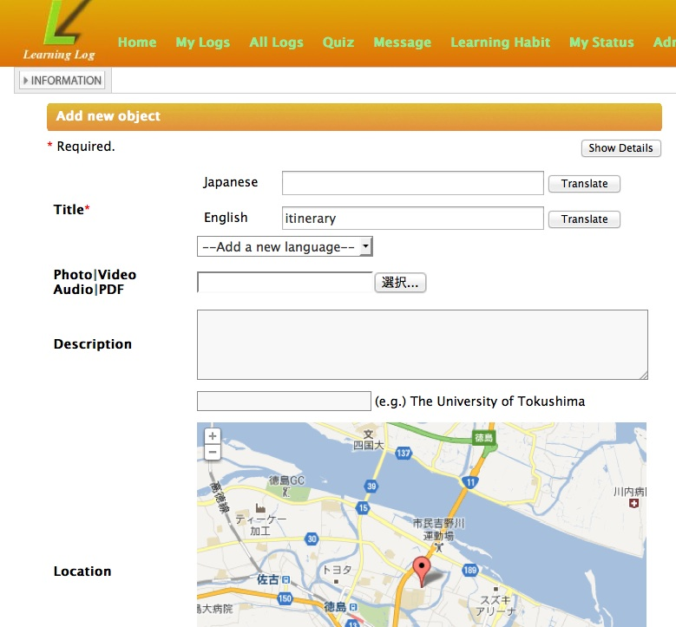
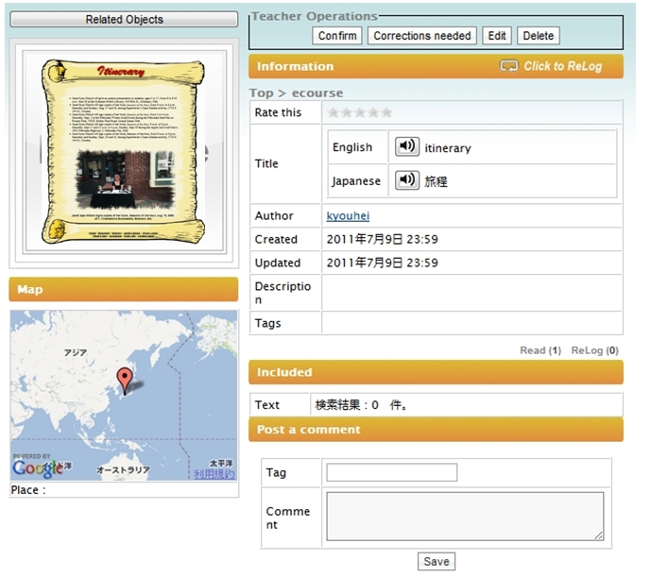
SCROLL(System for Capturing and Reminding of Learning Log) is a client-server application, which runs on different platforms such as Android mobile phones and PCs. Users can register what they have learned anytime, anywhere (cf. Figure 1). The registered object is called as a ubiquitous learning log object (ULLO). They can take quizzes made from their ULLOs for recalling them (cf. Section 2.2.1) The System lets learners share their ULLOs. The learners are able to watch other learners’ ULLOs (cf. Figure 2). If they like other learners ULLOs, they can “relog” them to their own pages just like “retweet” in Twitter so that ULLOs uploaded by other learners can be their own ULLOs.
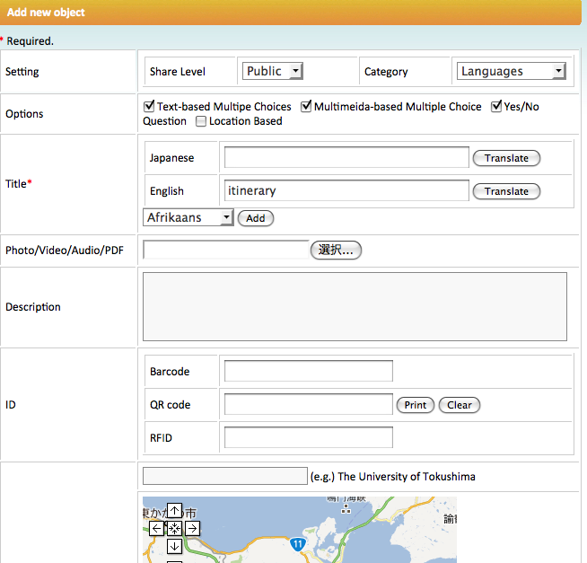

Figure 1 Learning log upload interface Figure 2 Learning log interface

Using this system, teachers can grasp what their students have learned outside the class (informal settings). For example, they ask their students to record the words that they have learned into SCROLL as ULLOs. In the next class, they make a reflection using their students’ ULLOs. Through this process, they can check whether the ULLOs given by their students are correct or not, and allow their students to share their knowledge. In this way, SCROLL enhances and integrates both formal and informal learning.
The past case studies demonstrated that the system helps users to remind and share ubiquitous learning experiences. The experimental group learned more words with uploading less words than the control group (Uosaki et al. 2012a), More involved in SCROLL, More they learned vocabulary (Li et al. 2012), The experimental group retained more vocabulary 2 month after the experiment session than the control group (Uosaki et al. 2012b).

Quiz in Learning Log System
According to Atkinson and Shiffrin (1968), memories can stay in the short-term “buffer” only for a limited period of time while they are strengthening their associations to be stored in long-term memory. Therefore the System is designed to support retaining vocabulary on the ability of long-term memory by giving quizzes.
The system gives learners quizzes to help them retain their vocabulary. It generates quizzes automatically based on ULLOs registered, reclogged, and viewed by the learners. Quizzes will be generated until they give them correct answers (Figure 3).

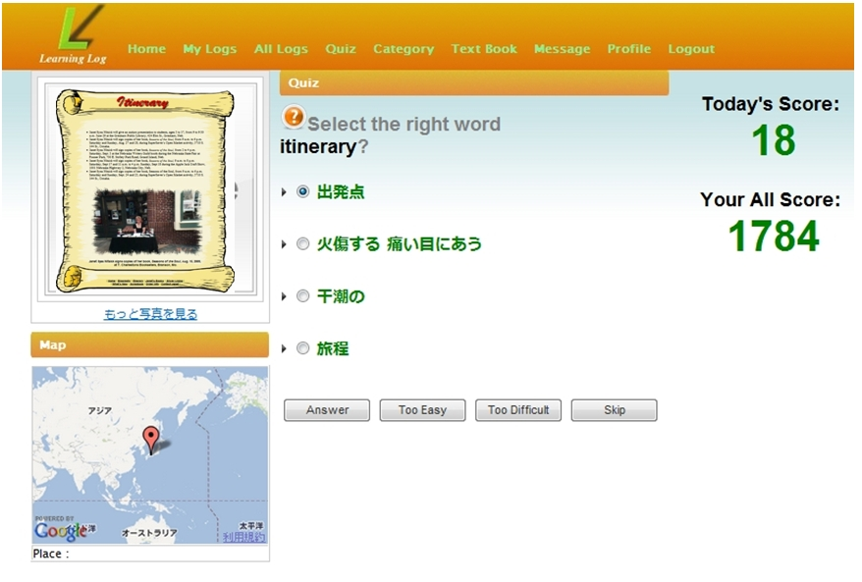

Figure 3 Quiz interface

After a certain interval, the system gives them quizzes which they have answered correctly to make sure if they are retaining their vocabulary. By using this methodology, it is expected that their short-term memory will be reinforced into long-term memory. Logs of all the quizzes are stored to be analysed and evaluated. Wrong-answer rates and difficulty-level choices from “too easy” to “too difficult” reflect the quiz generation. Difficulty level adjustment is made in order to facilitate their learning processes. If they challenge quizzes, they can accumulate the scores, which are shown in the right-hand side of the screen: Today’s Score and Your All Score. It is expected to motivate them to solve more quizzes.

KEYS TO SUCCESSFUL IMPLIMENTATION OF MOBILE LEARNING

Important Factors for Successful Mobile Learning
Takeuchi et al. (2008) have pointed out that in order to implement CALL, there are two important factors: 1) affordance and 2) transparency. We believe that these two factors are also vital for creating a mobile learning environment. In addition, we assert one more point: 3) sustainability. These three factors are discussed more in details below.

1) Affordance
Technology side or technology system designers should be aware of the importance of creating interface with high degree affordance in any learning environment. The concept of ‘affordances’ was originally coined by Gibson (1977). According to Gibson, action and perception are linked through real world objects that afford certain forms of action possibilities for particular species or individuals. The term, affordance is often used in the context of human–machine interaction to refer to those action possibilities that are readily perceivable by an actor. High degree affordance means users are able to guess how to use or proceed without being instructed. Thus, this condition can also be called user-friendly interface.

2) Transparency
Takeuchi et al. (2008) described “transparency” as “low sense of existence of medias in learning”. According to them, any media, as mediators of teaching and learning process, should not annoy both learners and teachers. Otherwise their attention would go to medias themselves and they would be less concentrating on their original purpose: learning/teaching. Bax(2003) insisted that computers will not be in the center of any lesson, but they will play an important part and still they will go almost unnoticed. The same is true with mobile devices. Unstable internet connection, short-life battery would be taken into account in this aspect.

3) Sustainability
According to JISC (Joint Information Systems Committee (UK)), Sustaining and Embedding Innovations Good Practice Guide notes, “Sustainability in innovation projects can be defined as embedding change as well as maintaining and enhancing project outcomes”. “Sustainability” includes to leverage the functions already available, to remove existing barriers, and to develop teaching/learning tools or materials. These elements are so vital that without them, it would be far from retaining efficient mobile learning initiatives.

Four Influential factors
What factors will influence successful mobile learning? In this section, we will pick out four influential factors and show guiding principles to assess the feasibility of successful mobile learning implementation. The assessment checklist for implementation possibility of mobile-based learning is shown in the Section 3.2.5 (Figure 4 and 5).

Factor 1: Management
In order to manage mobile learning initiative effectively, obtaining senior level buy-in is inevitable: No budget, no implementation. As Vavoula et al. (2004) has pointed out, the cost of the technology, the infrastructure and the services and applications are important issues when implementing mobile learning. As a general advice, institutions should try to make use of what is already in place in order to keep costs down. If every student reports smart phone owners, then it is easy to carry out mobile learning without budget difficulties. Since smart phones are prevailing rapidly, it is expected most students in classroom own them. In this case, purchasing some devices and lending them only to those who do not own them might be another possibility with low-cost performance.

Factor 2: Instructors
For successful implementation of mobile-based learning, one of the most important things is the instructors’ motivation whether they are really for mobile-based learning. Without their willingness, it is hardly possible.

Factor 3: Class Setup and Curriculum
Even though teachers have a high motivation, if they have to follow the strict teaching guidelines including teaching method, teaching materials, implementation is far from possible. They need to have a freedom in making decisions of what kind of class they run including learning approaches, teaching materials, seating arrangement and so on. Generally mobile learning fits task-based, interactive and collaborative learning. It is reported that traditional seating arrangement (desks all lined up and all the students face the teacher and a blackboard) makes students less active, less cooperative, less engaged in learning. In order to maximize the learning opportunities, traditional lecture style class is not recommendable. This is endorsed by the study from the National Training Laboratories (2005) which reported that only about 5 percent of the information delivered through lecture was retained. Compare that with retention rates at 50 percent for discussion group and 70 percent for practice by doing. Even higher, at 80 percent, was retention by students teaching others. Thus successful mobile learning depend much on instructors’ freedom in running class.

Factor 4: Learners
Even though schools have budget (Factor 1), teachers have a high motivation (Factor 2) and have a freedom (Factor 3), we cannot expect effective learning without learners’ active participation. This final factor is most important and most difficult. It has been a major research topic since early 20th century in the field of pedagogical psychology. According to Noels (2001), motivation can be generally categorized into two types: intrinsic and extrinsic motivation. It is argued that Deci and Ryan’s Self-determination theory (SDT) could describe one’s motivation in more understandable way. According to Ryan and Deci (2000) there is a self-determination continuum ranged from non-self-determined to self-determined which is subdivided into three parts: motivation, extrinsic motivation and intrinsic motivation. It is explained that the more self-determined, the more motivated. Thus, our general advice would be to let students think that learning is not forced and that it is determined by themselves. First ask them why they learn and let them make a practical goal setting of their learning (eg. TOEIC600 points). This process is important. Without active use of mobile learning system, any ideal m-learning environment could be worthless. What they call, we have piped unto you and ye have not danced. It is also important to let them keenly sense that in order to achieve their goal in-class learning is not sufficient and that outside-class, anytime-anywhere-based ubiquitous learning is inevitable. Generally speaking, students are busy, small-step style where the task can be achieved for a short period of time is recommended. Though it is believed that intrinsic motivation is better than extrinsic one, still it might be necessary to inspire some extrinsic motivation such as introducing a reward system where students’ hard works would reflect their grades. Putting these factors into consideration, an effective mobile learning would be realized.

Before-you-start checklist
1 Management (budget/device)
Figure 4 will show you whether your budget and students’ device condition fit for seamless mobile learning. If your condition fits, you can go to Section 3.3.

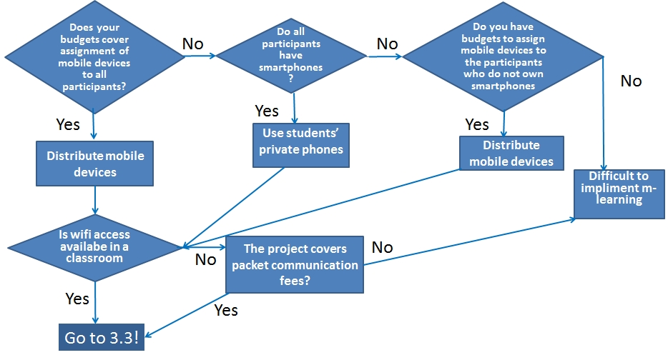

Figure 4 Budget/devices checklist

2 Contents
Figure 5 will show your condition fits for seamless mobile learning based on your freedom to choose teaching/learning materials. If you are totally free got to Section 3.4 and if the freedom is limited, go to 3.5 accordingly.
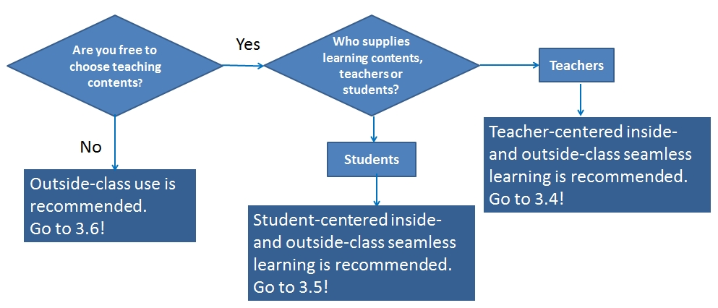

Figure 5 Content checklist

Eight Considerations: Practitioners’ Perspective
In order to make the most use of mobile learning environment, it is vital to grasp the environment: what is available, what is not available, and learners’ computer literacy and mobile literacy. The followings are some of the points that the practitioners should keep in mind.

Conduct questionnaire
At the beginning of the semester, it is highly recommended to conduct questionnaires to grasp learners’ computer literacy and mobile environment. The followings are sample questions:
- Do you have mobile phones? Is it smartphone?
- Do you have computers at home? Is it internet connected?
- Do you share computers with your family? Do you have one of your own? (Figure 6 )
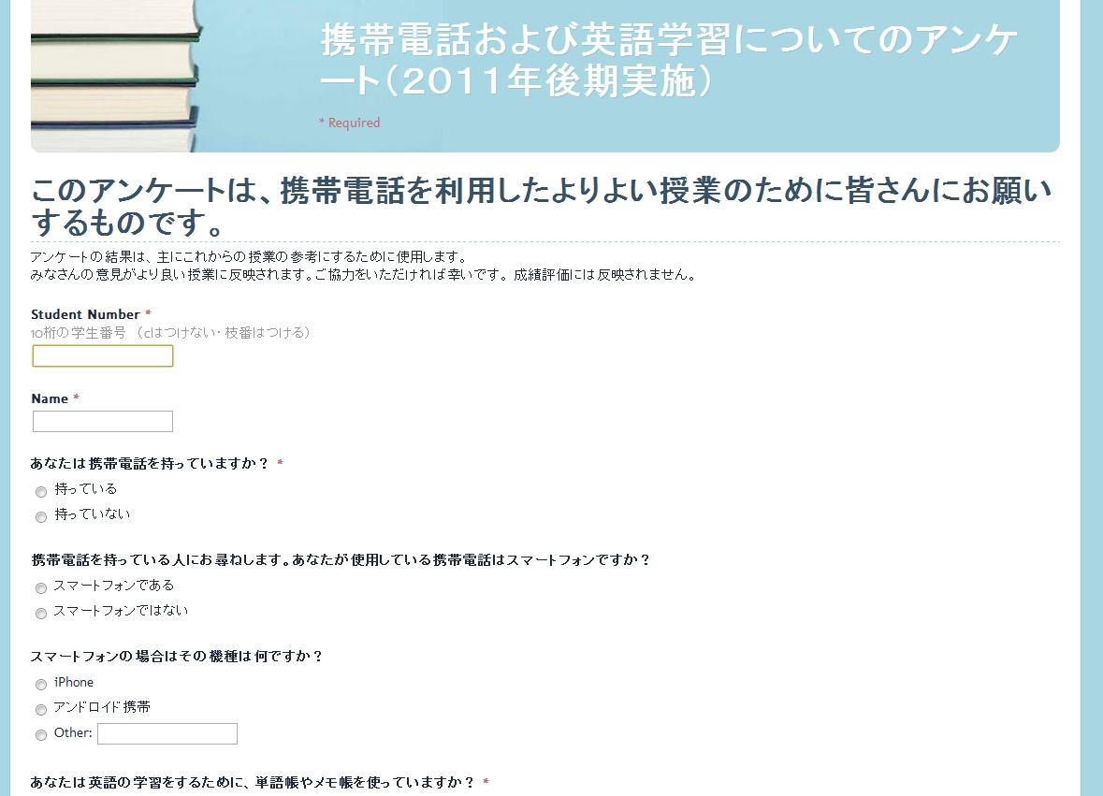

Figure 6 Questionnaire
cf. URL https://docs.google.com/spreadsheet/viewform?formkey=dDlKMjdPUXNiQk56ZFRvcE00dUhwanc6MQ#gid=0

Initial registration
Create students accounts beforehand and make a user list with the name, email address, password, username, device number. Print it out and cut each and hand them to the students on the first day (cf. Figure 7).


Figure 7 Memo slip with user ID and password

Numbering of devices to be distributed
It is highly recommended to number the devices to be used and to make a list with student numbers, names, device numbers, and seat numbers. It is very convenient to make device numbers and seat numbers identical if possible (cf. Figure 8).

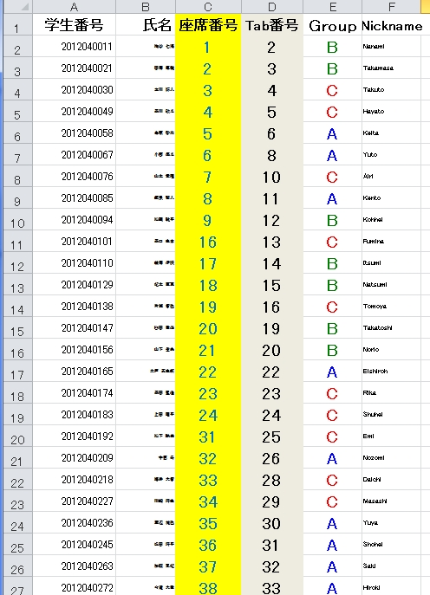
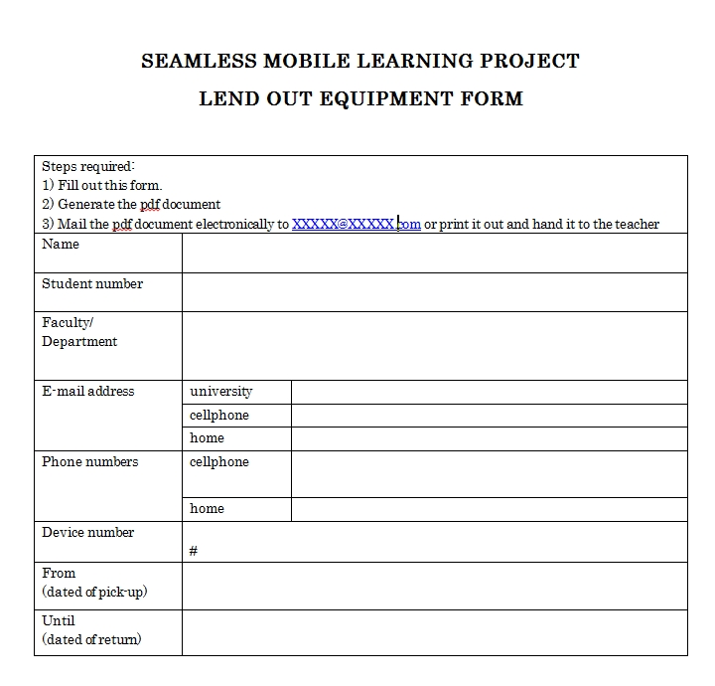

Figure 8 Device number list Figure 9 Lend Out Equipment Form

Prepare Lend Out Equipment Form
Distribute lending forms when you distribute devices asking the students to fill in the form with their contact information such as their e-mail addresses and cellphone numbers (cf. Figure 9).

Prepare the contact information slip for each device
It is highly recommended to post or insert the contact information slip with the name of the project leader, his/her e-mail address and cellphone number in case someone lost his/her device. There will be a possibility that the finder may get contact with the project leader (cf. Figure 10).

Charging devices
It is an important job for the practitioners to charge devices before they are distributed. It means lots of electrical outlets needed (cf. Figure 11). After being distributed, it would be each student routine work to charge the device every day.

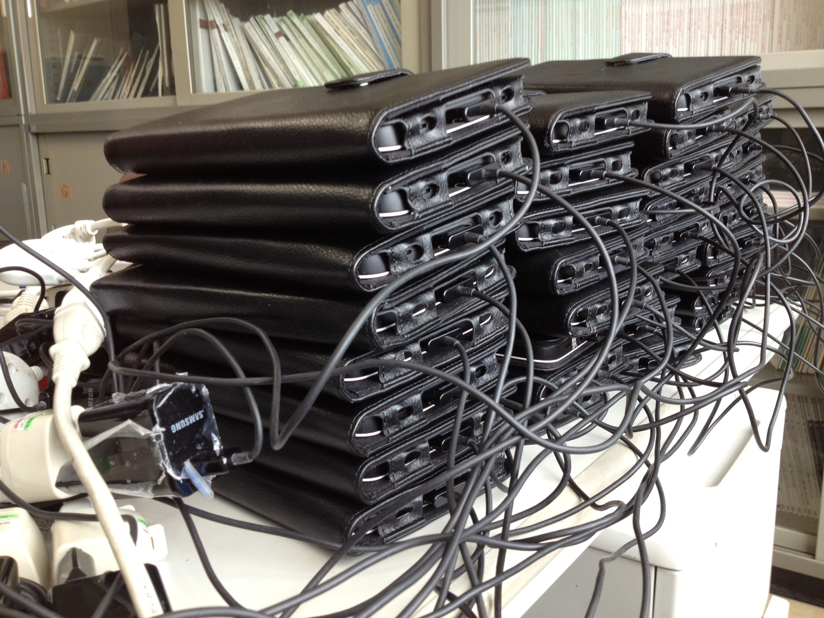
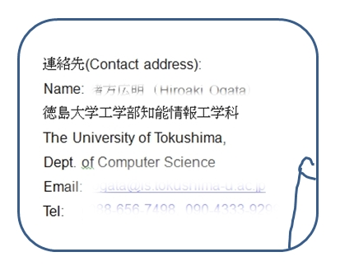

Figure 10 Contact information slip Figure 11 Devices being charged

Privacy
Privacy is an important issue to be considered when taking photos and upload them as ULLOs. It is recommended to advice students not to take a photo with someone’s face in it or the ones which are considered too private.

Comment column
A comment column in each ULLO interface is for asking questions or exchanging information. Therefore let students note that when they write comments on ULLOs, they should not write things off-topic.

Creating contents for classroom use

SMALL System
Uosaki et al. (2012a) proposed SMALL System (Seamless Mobile-Assisted Language Learning Support System). It is based on SCROLL and linking function between inside- and outside-class learning is newly added. It aims to entwine in-class learning with out-of-class learning. When learners upload what they have learned outside-class to the System, then it links it with the one used in the textbook and vice versa. Therefore it fits for formal learning.
At first, teachers upload textbook data (PDF or text) to the system (Figure 12). Students can read textbook files anytime anywhere for previewing and reviewing with mobile devices just like a paper book.

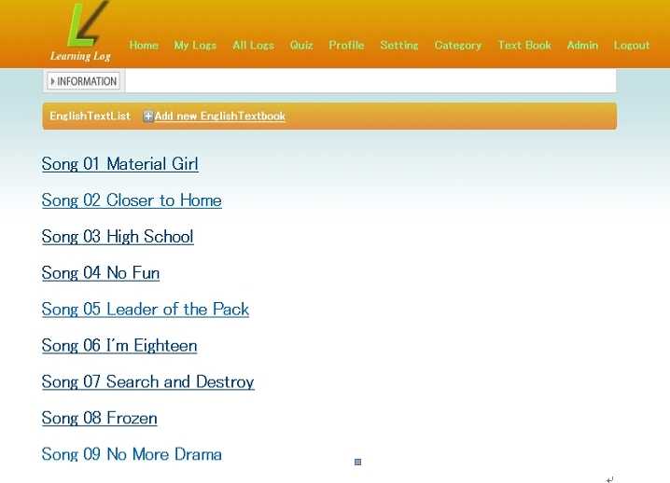

Figure 12 Content upload interface
In the electronic textbook, registered words are hyperlinked and when the teacher clicks them, a side bar pops up and it shows names of the students who registered them so that the teacher will be able to know how many students and who have registered them (Figure 13).
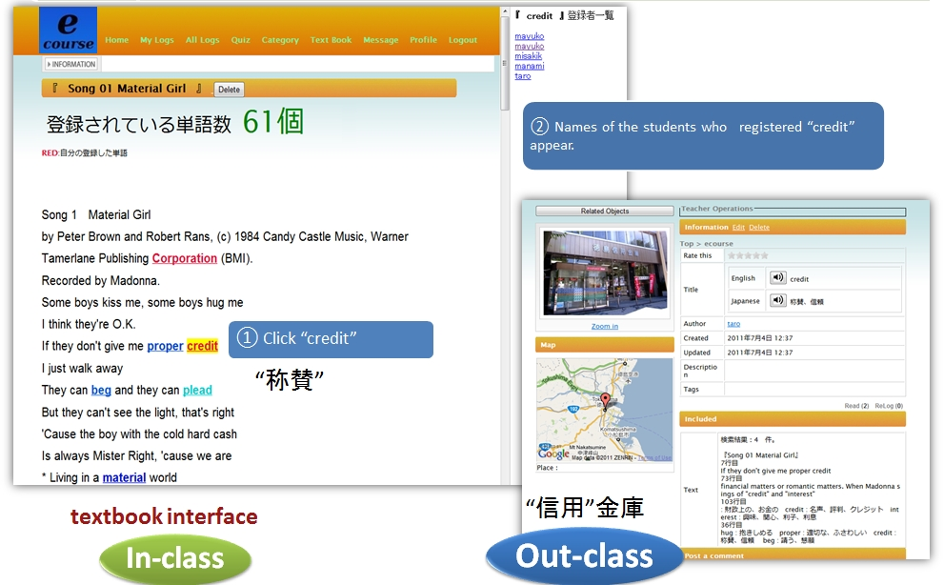
Figure 13 Textbook interface

The electrical textbook can be accessed through internet-connected PCs and smartphones. They can use during class and at home. Teachers registered the target words of each chapter before class and let them view target words as a preview assignment. Students can “relog” them if they are unknown words and challenge quizzes.

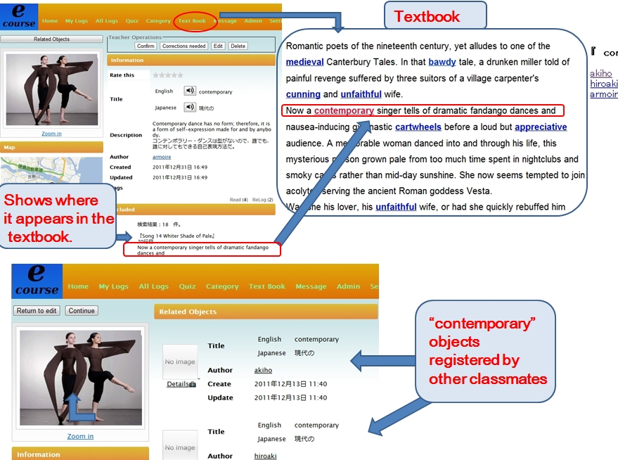

Figure 14 Link between in-class learning and out-of-class learning

As mentioned, this system aims to entwine out-of-class learning with in-class learning. Figure 14 shows how in-class vocabulary learning and out-of-class vocabulary learning are linked. a student, registers “contemporary” during his out-of-class learning, then the system shows him the textbook context where it appears as well as its page and line number. Then he can realize that he has already learned it in the textbook during his in-class learning. That way it reminds him of what he had learned but forgotten already.
The System also entwines students’ self-learning with that of the others. It shows the “contemporary” objects registered by other classmates. When he clicks them, he can learn other contexts where “contemporary” is used. This linking function is significant because, as mentioned earlier, students need to encounter as many different contexts as possible to grasp the true meaning of the word. For another reason, as a general concept, people are likely to forget what they have learned. In fact forgetting learned vocabulary is a serious problem during learning English vocabulary (Chen and Chung 2008). Even though the student felt “contemporary” was totally new to him, the system lets him know that he has learned it before in the textbook.

Creating student-centered contents for inside- and outside-class learning

SMALL System learning based on student-centered contents
Students can upload contents just as teachers do on the same page shown in Figure 12. Looking for some articles which they get interested in (any topic will do such as music, sports, movies, TV shows) and upload them so that they can share. They are supposed to present concerning the material they chose during class in turn. It is recommended to do it as a group work.

Creating contents for outside-class use

SCROLL for informal learning – Give assignments to register words to SCROLL
When teachers should follow the teaching guideline strictly and do not have freedom to choose teaching/learning materials, SCROLL would be mainly for outside-class learning. According to Nation (1990), 5 to 16 exposures are necessary to fully acquire a word. SCROLL is a good tool to assist learners to reinforce word-meaning connection by giving them a quiz and recommending ULLO where they come across the place where they learned it.
A top ten upload ranking list (names of the learners who uploaded top most to 10th) is shown on each user’s top page, which is expected to stimulate them to upload more words. As mentioned before, they can accumulate the scores when they challenge quizzes. The score display is expected to motivate them to solve more quizzes. Let them note that their commitment to SCROLL learning reflected their grades.

LEARNING SINARIOS IN MOBILE ENVIRONMENT featuring mobile language learning

Case Study 1 ( Li et al. 2012)
Target : Japanese language learning
Learning Style: informal learning (no classroom use)
Device used: Galaxy Tab SC-01C produced by Samsung were delivered to each student on one to one basis.
Eleven international students voluntarily participated in a SCROLL experiment which lasted from April 15 to July 11 in 2011. All of them have been in Japan for less than a year. The experimenter encouraged them to learn Japanese words in their daily lives and upload them to SCROLL and take quizzes on the System. They took vocabulary tests of what they have learned. The results showed that the learners benefited from the system and the context based recommendation and learning habit based prompting also motivated them to study more.

Case Study 2 (Uosaki et al. 2012a)
Target : English language learning
Learning Style: formal learning (in-class and outside-class use)
Device used: Galaxy Tab SC-01C produced by Samsung were delivered to each student on one-to-one basis.
Thirty-eight Japanese university freshmen participated in the experiment using SMALL system(cf.3.4.1). They were divided into two groups: the experimental group and the control group. The evaluation lasted from June 14 to July 12, 2011. They could use classroom PCs and their home PCs. They learned vocabulary through the textbook during class. They were assigned to learn vocabulary and uploaded what they have learned out-of-class to the System. They recorded the hour they spent for vocabulary learning outside-class (cf. Appendix 1). The results showed that the experimental group uploaded less words, but learned more words than the control group and that the entwining function showed statistically significant effectiveness when excluding two exceptional cases. The subjects predominantly used mobile devices during out-of-class learning.

Task-based learning (on-going project)
Task-based language learning or TBLL is a popular learning method based on ‘experiential learning’ proposed by Dewey (1938). It puts much emphasis on learning by doing. We are now developing a new function to encourage learners to get involved in task-based learning so that they can actually experience learning situations such as shopping, asking the way, visiting a doctor and so on (cf. Figure 15 and 16).
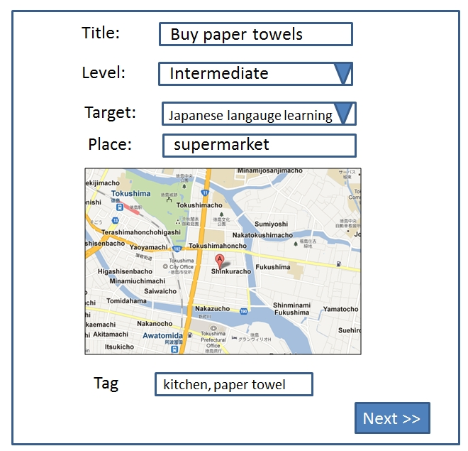
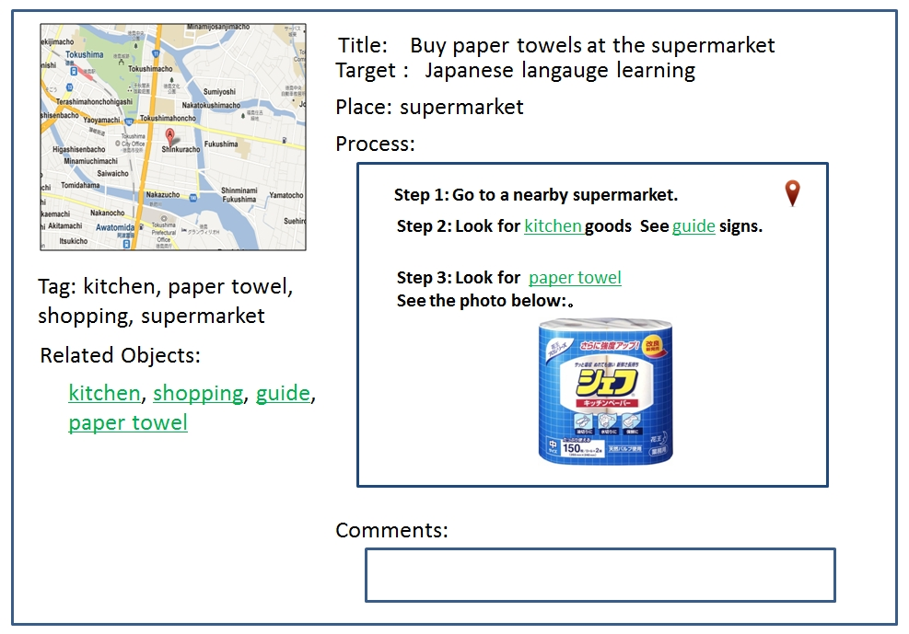

Figure 15 Task-based learning Interface (1) Figure 16 Task-based learning Interface (2)

Navigator System (on-going project)
As mentioned before, the ubiquitous technologies have enabled us to personalize our learning by fetching the most appropriate contents to most appropriate learners at the most appropriate time and place. SCROLL has a GPS function based AR (augmented reality) Navigator System (Mouri et al. 2012). It aims for letting learners aware of ULLOs around them and encouraging them to learn new knowledge by recommending them and guiding them to the ULLOs in the real environment (Figure 17 and 18).

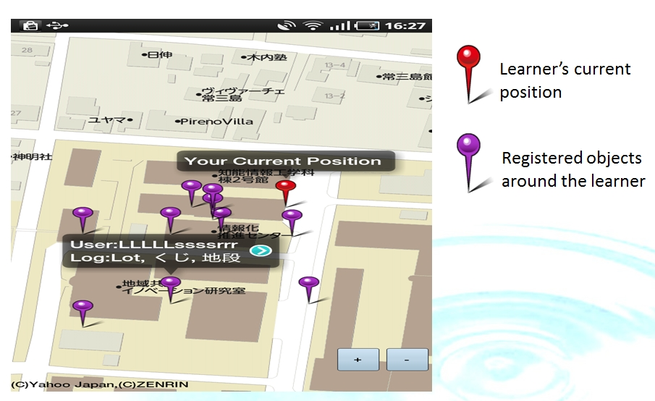
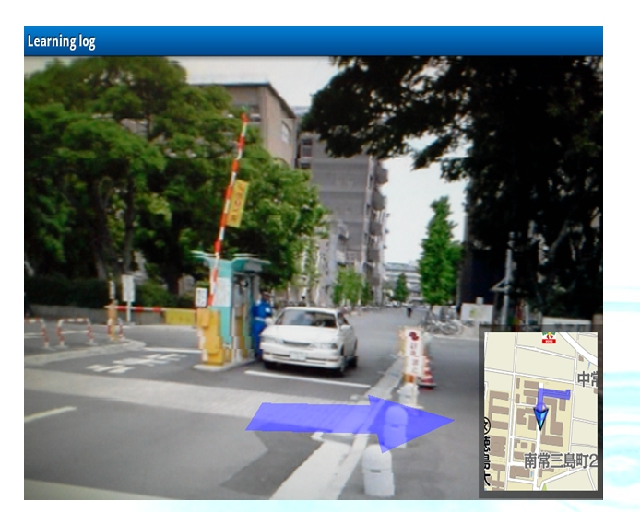

Figure 17 AR Navigator Interface (1) Figure 18 AR Navigator Interface (2)

Language Learning Scenarios
Some learning-by-doing scenarios using SCROLL are suggested in this section. For the sake of the instructors’ convenience, lists of necessary things, and things to do before class are provided.

Orienteering on Campus using mobile devices (task-based learning)

(1) Activity Outline
Students go outside classroom with mobile devices such as smartphones, tablets and do orienteering-based activities
(2) Target Language Skill: Speaking, Reading
(3) Level: beginner to intermediate
(4) Activity Style: pair work / group work
(5) Before class: Register ULLOs here and there on campus. Register questions on “description” area on the registration interface. (cf. Figure 19)

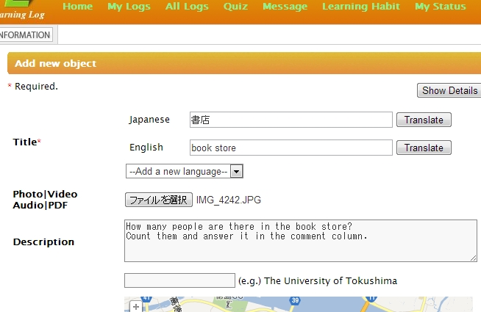

Figure 19 Description area in Learning log upload interface

Procedures

1) Make pairs or groups and let them go to the places instructed by the teacher.
2) Then the students receive push mode messages which inform them that there are some ULLOs around them. Read “Description” and do the task as instructed. They input an answer in a comment column (cf. Figure 20). Another possibility is to answer the question orally using voice recorder and upload the sound files to some cloud area or the instructed sites such as dropbox, shareholder at LMS (Learning Management System). Then Go to another object that instructs next task. They are not allowed to use their native language. (cf. Appendix 2).
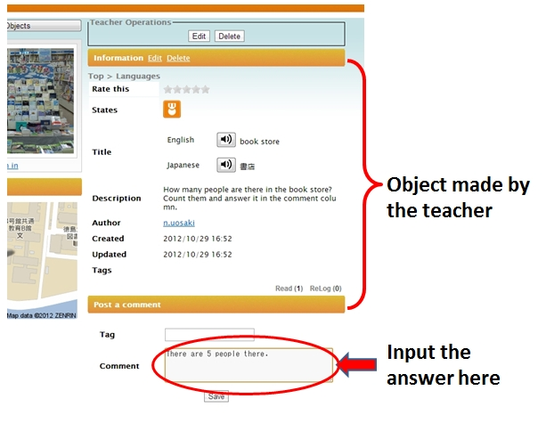

Figure 20 Comment column in Learning Log Object interface

3) The number of the task should be the same with the number of the group members so that every single member could be a leader of at least one task.
4) If they have some problem or trouble, they make a call to the teacher, who gives them some advice or new instruction according to their situation. As a rule they are supposed to use the target language while communicating with their teacher.
5) The teacher checks the e-mails/voice mails sent by the students and give them the next task
6) The pair/group who finished all the tasks will be awarded and it reflect their grading.

- Points:
1) Make pairs or groups and let them go to the places instructed by the teacher. It is appropriate to give them four to five tasks during one class. Accordingly, make a group with 4 to 5 students each.
2) Drawing can be one of the tasks.
3) Use “describe ….” in instructions so that the students can learn how to describe the situations which they encounter in
4) We can make it a competition-style where the group who finished all the tasks first is awarded.
5) We can make the students create tasks themselves.

Interviewing using Smartphones
(1) Activity Outline
Interview activity: Peer-to-peer interviews and if possible, interviews with international students using smartphones. The students uploaded the recorded files of interviews to the System or LMS (Learning Management System) and shared the files by listening and made summary reports which were also uploaded to the LMS.
(2) Target Language Skill: Speaking
(3) Level: Intermediate to advanced
(4) Activity Style: pair work

Procedures
- Make pairs and let them interview with each other on a given topic. Prepare questions before interview sessions. Make recording interview session using voice recorder function of smartphones and upload the recorded file to the System (Sound file upload is still under development).
- After the interview session, let them make a summary of the interview and submit the file to the System.

Hints
1) If the students are beginners and feel it hard to make conversation continue, one solution is to deliver them sample dialog video clips (or sound clips) and let them practice in a pair-work style. (cf. ‘deliver’ can mean ‘upload files to LMS, Google+, Dropbox, iCloud, Youtube etc.)
2) Delivering useful phrases for interviewing, either it is digital or analog, might help.(cf. Appendix 3).
3) It will stimulate other students to upload best performers’ video clips or recorded files to LMS, dropbox, or any form of sharable files
4) Uploading all interviews and then vote for the best interviewer might be another in/out-class activity. The best interview might deserve an add-on to his/her grade.
.

Conclusions and Future works
This paper has set pedagogically-based guidelines for instructors or any kind of parties who are interested in ubiquitous seamless learning to implement an environment using SCROLL. We are earnestly hoping that SCROLL will be able to contribute to the development of ubiquitous mobile learning in any level of education from K-12 to higher education all over the world.
As our future work, utilizing sensor technology, more customized learning recommendation system is under development so that the system can give the learners more recommendation at more appropriate timing and more appropriate places. We believe that the smartphones will be equipped more sophisticated kinds of sensors in the future and the device will know learners better to catch their learning habits more accurately.

Acknowledgements
This research work was supported by PRESTO from Japan Science and Technology Agency, and the Grant-in-Aid for Scientific Research No. 21650225 from the Ministry of Education, Science, Sports, and Culture in Japan.

References
Atkinson, R. C. and Shiffrin, R. M. (1968). Human memory: A proposed system and its control processes, In K. W. Spence and J. T. Spence (Eds), The psychology of learning and motivation, Vol. 2, pp.89–195, London: Academic Press.

Bax, S.(2003). CALL – past, present and future. System, Vol.31, pp.13–28.

Carlson, S. (2002). Are personal digital assistants the next must-have tool?, The Chronicle of Higher Education, October 11th, 2002.

Chambers, A., and Bax, S. (2006). Making CALL work: Towards normalization. System, Vol.34, pp.465–479.

Chinnery, G.M. (2006). Emerging technologies. Going to the mall: mobile assisted language learning’, Language Learning & Technology, Vol. 10, No. 1, pp.9–16.

Deci, E. & Ryan, R. (1985). Intrinsic motivation and self-determination in human behavior. New York: Plenum Press.

Dewey, J. (1938). Experience and Education, Kappa Delta Pi

Gibson, J. J. (1977). The Theory of Affordances. In Perceiving, Acting, and Knowing : Toward an Ecological Psychology, Eds. Robert Shaw and John Bransford, pp. 67–82. Hillsdale, NJ: Lawrence Erlbaum Associates.

Herman Miller, Inc. Rethinking the Classroom: Spaces Designed for Active and Engaged Learning and Teaching. Retrieved August 17, 2012 from http://www.hermanmiller.com/research/solution-essays/rethinking-the-classroom.html

Hou, B., Li, M., Ogata, H. and Yano, Y. (2010) Supporting Japanese mimicry and onomatopoeia, learning using sensor data, International Journal of Mobile and Blended Learning, Vol. 2, No. 1, pp.40–54.

JISC : http://www.jisc.ac.uk/
(https://mobilelearninginfokit.pbworks.com/w/page/42115382/Sustainability)

Kukulska-Hulme, A., Sharples, M., Milrad, M., Arnedillo-S´anchez, I., and Vavoula, G. (2009). Innovation in Mobile Learning: A European Perspective. International Journal of Mobile and Blended Learning, Vol.1, No.1, pp. 13–35.

Li, M., Ogata, H., Hou, B., Uosaki, N. and Yano, Y. (2011). Development of personalized and, context-aware model in learning log system, Workshop Proceedings of the 19th International Conference on Computers in Education, Asia-Pacific Society for Computers in Education, Chiang Mai, Thailand, pp.321–328.
Mouri K., Ogata H., Li M., Hou B., and Uosaki, N., Learning Log Navigator: Augmented Awareness Past Learning Experiences Proc. of IIAI International Conference on Advanced Applied Informatics (IIAI AAI 2012), pp. 159 - 162, Fukuoka, Japan, 20-22 Sept. 2012.

Nation, I.S.P. 1990. Teaching and Learning Vocabulary, New York: Newbury House.

National Training Laboratories Institute for Applied Behavioral Sciences. (2005). The Learning Triangle: Retention Rates from Different Ways of Learning. Bethel, Maine.

Noels, K. A.(2001). New Orientations in Language Learning Motivation: Towards a Model of Intrinsic, Extrinsic, and Integrative Orientations and Motivation. In Z Dornyei & R. Schmidt (Eds.), Motivation and Second language learning pp.43–68. Honolulu: University of Hawaii Press.

Ogata, H. and Yano, Y. (2004). Context-aware support for computer-supported ubiquitous learning, Proceedings of IEEE WMTE2004, pp.27–34.

Ogata, H. and Yano, Y. (2010). Supporting Awareness in Ubiquitous Learning, International Journal of Mobile and Blended Learning, Vol.1, No.4, pp.1–11.

Ryan, R. M. and Deci, E. L.(2000) Self-determination theory and the facilitation of intrinsic motivation, social development, and well-being, American Psychologist, Vol.55, No.1, Jan 2000, pp.68–78.

Sharples, M., Taylor, J., & Vavoula, G. (2007). A Theory of Learning for the Mobile Age. In R. Andrews and C. Haythornthwaite (eds.) The Sage Handbook of
eLearning Research. London: Sage, pp. 221–247.

Stockwell, G. (2007) Vocabulary on the move: investigating an intelligent mobile phone-based vocabulary tutor, Computer Assisted Language Learning, Vol. 20, No. 4, pp.365–383.

Takeuchi, O., Yoshida, H., Uosaki, N., Sumi, S., and Ikeda, M. (2008) CALL Jugyou No Tenkai (New Evolution of CALL Class) (in Japanese), Shohakusha, Tokyo.

Thornton, P. and Houser, C. (2005) Using mobile phones in English education in Japan’, Journal of Computer Assisted Learning, Vol. 21, No. 3, pp.217–228.

Traxler, J. (2005). DEFINING MOBILE LEARNING. Proceedings of the IADIS International Conference Mobile Learning 2005, pp. 261–266.

Uosaki, N. and Ogata, H. (2009). Supporting communicative English class using mobile devices, Proceedings of mLearn2009, Orlando, USA, pp.94–102.

Uosaki, N. Ogata, H., Li, M., and Hou, B. (2012a). Towards seamless vocabulary learning: how we can entwine in-class and outside-of-class learning, International Journal of Mobile and Learning Organization, Vol.6, No.2, pp.138–155.

Uosaki, N. Ogata, H., Li, M., and Hou, B. (2012b). Supporting English Vocabulary Learning with SCROLL, Workshop Proc. of CollabTech 2012, pp.9–14, Sapporo, Japan.

Vavoula, G.M., Lefrere, P., O'Malley, C., Sharples, M. and Taylor, J. (2004). Producing Guidelines for Learning, Teaching and Tutoring in a Mobile Environment. Proceedings of the 2nd IEEE International Workshop on Wireless and Mobile Technologies in Education (WMTE'04), p. 173.

Wang, M. and Jason, W. P. Ng. (2012). Intelligent Mobile Cloud Education: Smart Anytime-Anywhere Learning for the Next Generation Campus Environment. Proceedings of the 8th International Conference on Intelligent Environments (IE’12), pp. 149–156.

Appendixes
Appendix１
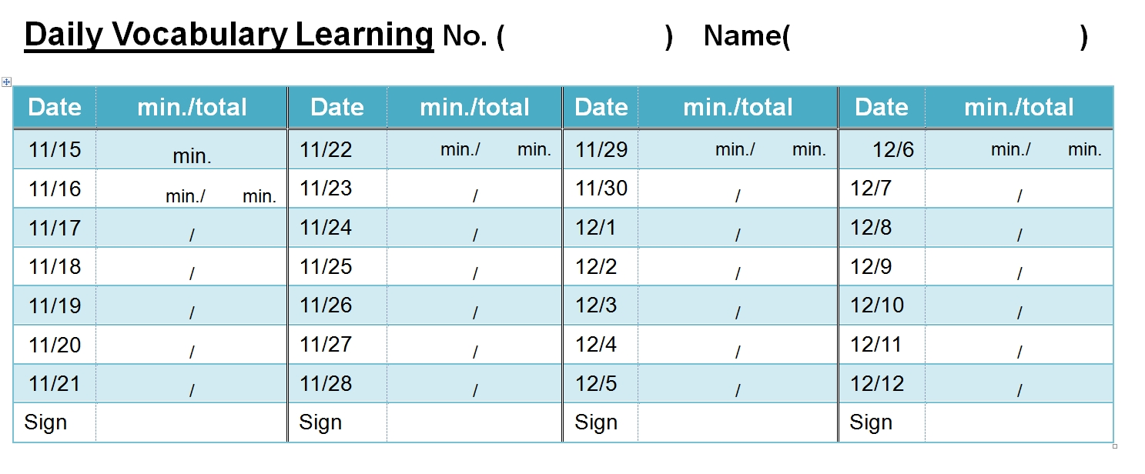

Appendix 2

Appendix 2: Sample Instructions
- Go to the gymnasium and describe what people there are doing.
- Go to the tennis courts and count the number of people who are playing tennis and describe them
- Go to the roof and describe what you see.
- Go to the café “XXX” , count the number of people who are sitting at tables and report today’s special lunch.
- Find some international students and ask them where they are from and their majors and so on
- Find at least three things which are orange, and name them.

Appendix 3: Useful expressions for interviewing
- Where are you from?
- What is your hometown famous for?
- What are your hobbies?
- Do you belong to any club or circle?
- What kind of sports do you like?
- What is your favorite food?
- What kind of music do you like?
- Do you have your favorite artist or bands?
- Do you have any plan for next weekend?
- What did you do during the holidays?

